Hospital Network

Simranjeet Singh
Bachelor of computer science
Chandigarh University
simranjeet0027@gmail.com

Abstract- In this modern era everything is interconnected for a seamlessly fast progression, each and every large organization having large infrastructure requires to communicate securely and swiftly. Universities, Big Offices, Hospitals require a good infrastructure to communicate which can only be achieved by computer Networking. Computer communication network is growing at a rapid pace, Computer communication networks are based on a technology that provides the technical infrastructure, where routing protocols are used to transmit packets across the Internet. Routing protocols specify how routers communicate with each other by transmitting information. The router has prior knowledge about the neighboring networks, which can help in selecting the routes between two nodes. There are various types of routing protocols being widely used. There are two different ways to configure routing tables in the router. They are static routing and dynamic routing. In this paper, we have analyzed and simulated a proposed wired Local Area Network using Static routing protocols. Therefore configuration of the network is done using static routing in CISCO packet tracer simulator.

Introduction
The main objective is to interconnect every single block and every single room of each block so that every computer in the hospital can communicate with any other computer in the hospital. There are few blocks in hospital premises located at a few distances from each other and every block has 20-25 computers and a few servers. This objective can be fulfilled by connecting every computer using any routing protocol. Static routing is used in this network. Static routing is easy to implement in small scale networks. They are very secure and predictable as the route to the destination is always remains the same. It doesn't require any routing algorithm or update mechanisms. Hence no extra resources such as CPU and memory is required. Static routing is simply the process of manually entering routes into the routing table of a device using its a configuration file that is loaded when the routing device starts up. In static routing, all the changes in the logical network layout need to be manually done by the system administrator. All these actions are performed in the Cisco packet tracer. Packet tracer is a visual simulation tool designed by Cisco systems that allow the user to create network topologies and imitate modern computer networks. The software allows users to simulate the configuration of Cisco routers and switches using a simulated command-line interface. Packet Tracer makes use of a drag and drop user interface, allowing users to add and remove simulated network devices.

Experimental setup
Network design is created keeping all the blocks and number of computers that are required to be connected. The design includes of 5 main blocks which are names as Emergency block, OPD block, Eye block, Dental block, and Education block. This design consists of 5 Routers, 9 Switches, 3 servers, and 170-200 computers.

Devices required
- Router- A router is a device like a switch that routes data packets based on their IP addresses. Router is mainly a Network Layer device.
- Switch – A switch is a multiport bridge with a buffer and a design that can boost its efficiency(a large number of ports imply less traffic) and performance. A switch is a data link layer device.
- Computers- A computer is a machine that can be instructed to carry out sequences of arithmetic or logical operations automatically via computer programming.
- Straight-through cable is a type of twisted pair copper wire cable for local area network (LAN) use for which the RJ-45 connectors at each end have the same pinout (i.e., arrangement of conductors).

B. Number of Devices used
- Emergency block has 1 router, 2 switches, and 48 computers.
- Dental block has 1 router, 1 switches, and 18 computers.
- OPD block has 1 router, 1 switch and 24 computer
- Eye block has 1 router, 1 switch, and 48 computers.
- Education block has 1 router,3 servers, 3 switches, and 53 computers.
First of all the routers and switches are placed according to the proposed design and computers are connected to them systematically. There are various techniques for making a connection. Topologies like bus topology, star topology, ring topology. Computers are connected to the switches in star topology
The second step is providing IP Addresses to computers and servers. An Internet Protocol address is a numerical label assigned to each device connected to a computer network that uses internet protocol for communication. An IP address serves two main functions that are host or network interface identification and location addressing. All the computers connected in the design are given separate IP addresses. Routers are also assigned with different IP addresses which act as a gateway IP address. Switches are connected with routers with point to point topology. All the routers are connected to each other in a bus topology.
Static routing is performed on all the routers to interconnect them. Static routing is easy to implement in small scale networks. They are very secure and predictable as the route to the destination is always remains the same. Static routing is simply the process of manually entering routes into the routing table of a device using its a configuration file that is loaded when the routing device starts up. In static routing, all the modification in the logical network layout need to be manually done by the system administrator
After all the technical part is over, time to test the created network. Testing can be done by sending a packet from one computer to the neighboring computers if this is successful then send a packet to another computer connected to another computer in the network. The result of the packet sent is shown in Cisco packet tracer. 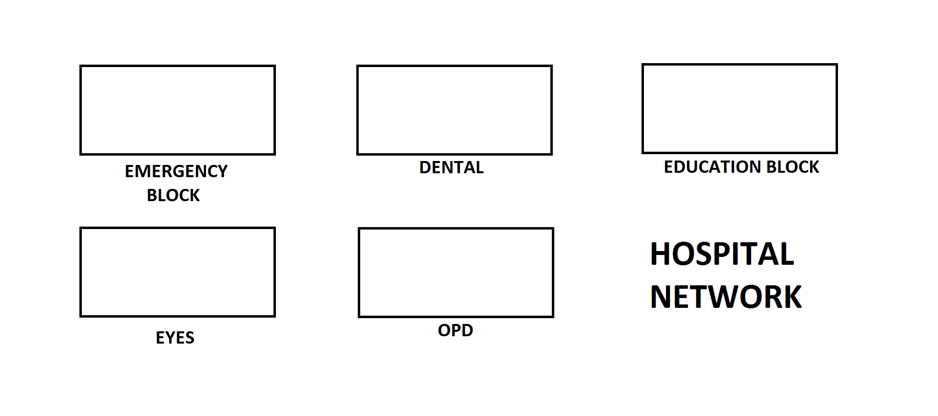

results
There is a working model of a hospital network in which 170-200 computers are interconnected with each other. All the computer have static IP addresses which can communicate with each other within the network.

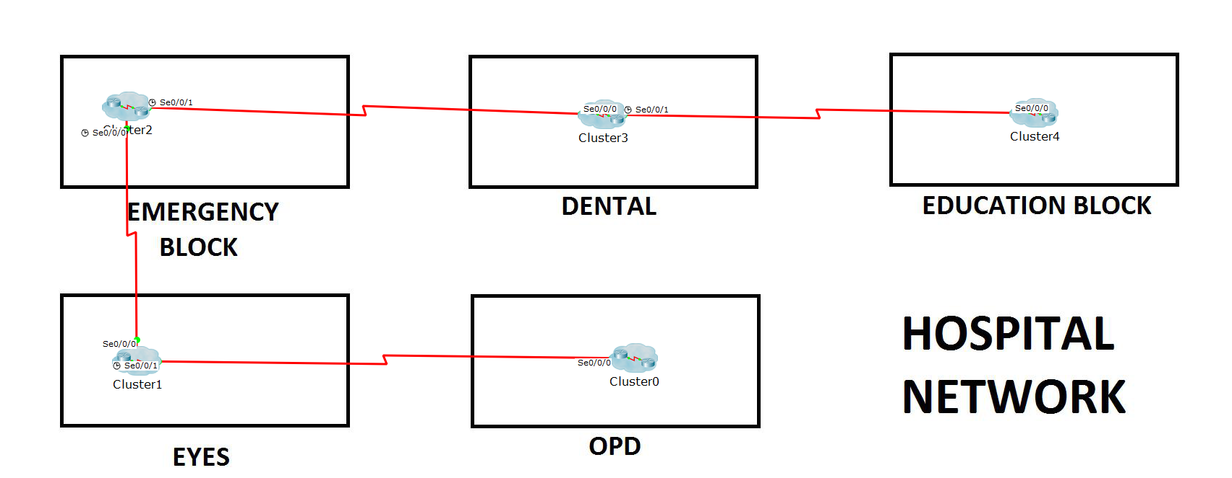
This network has 5 blocks in which there are router,switches, servers and computers are connected and every network has been clustered.

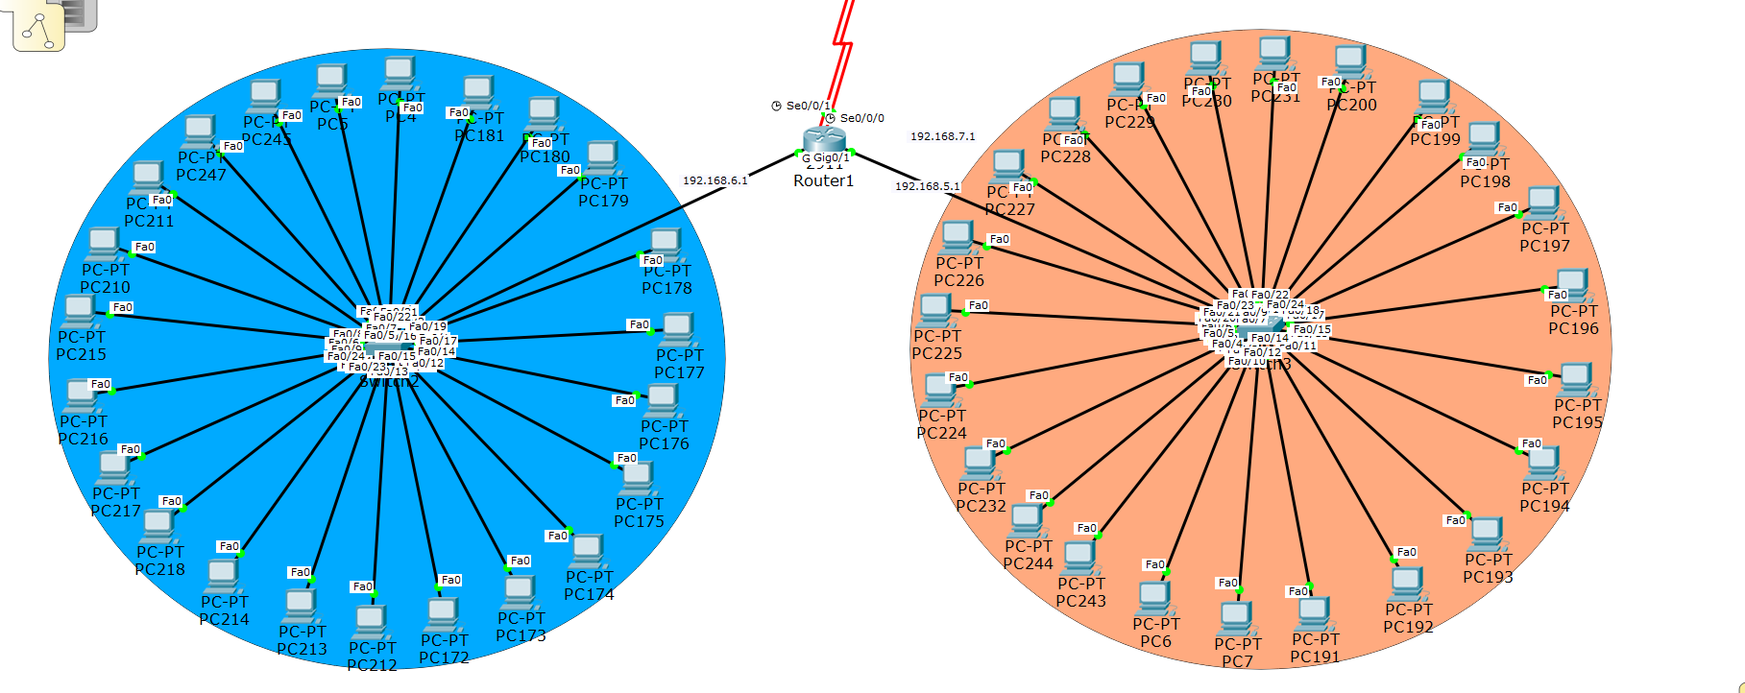
The above network represent emergency block in which there is one router, two switches and 48 computers.

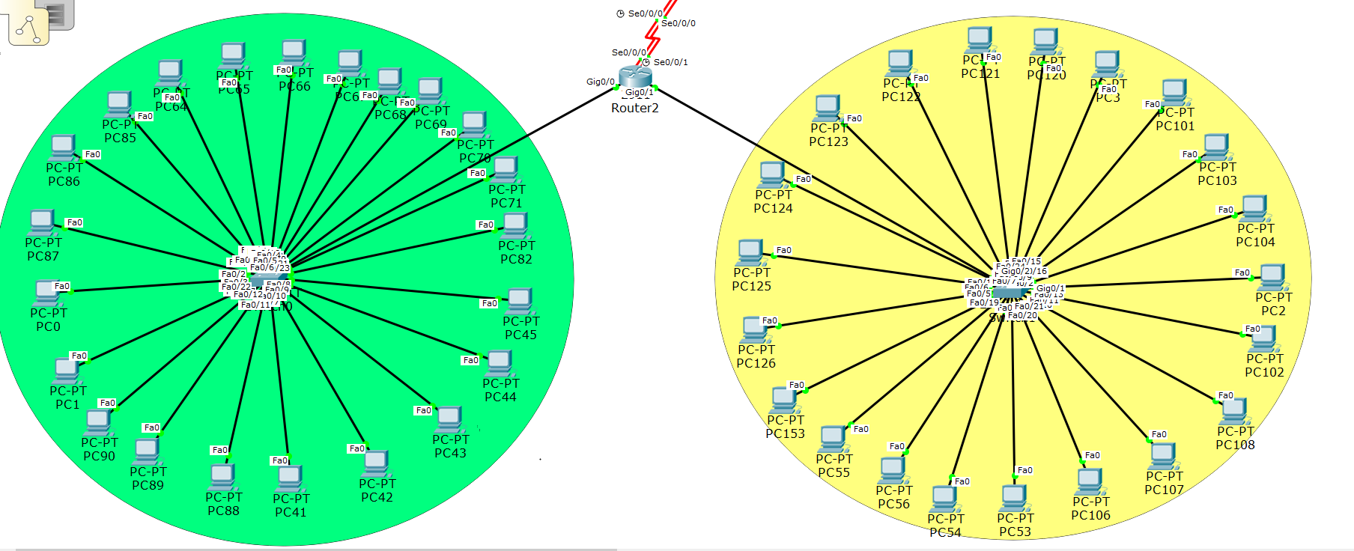
This is the network structure of eye block in which there is one router, two switches and 48 computers.
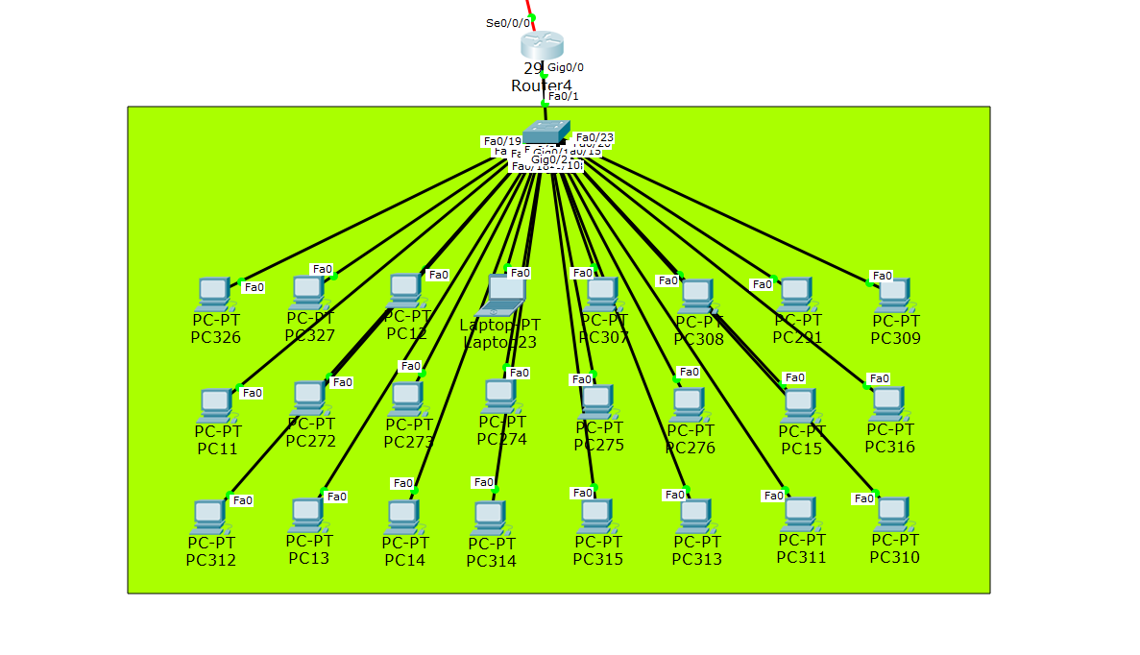
OPD block has 1 router, 1 switch and 24 computers.

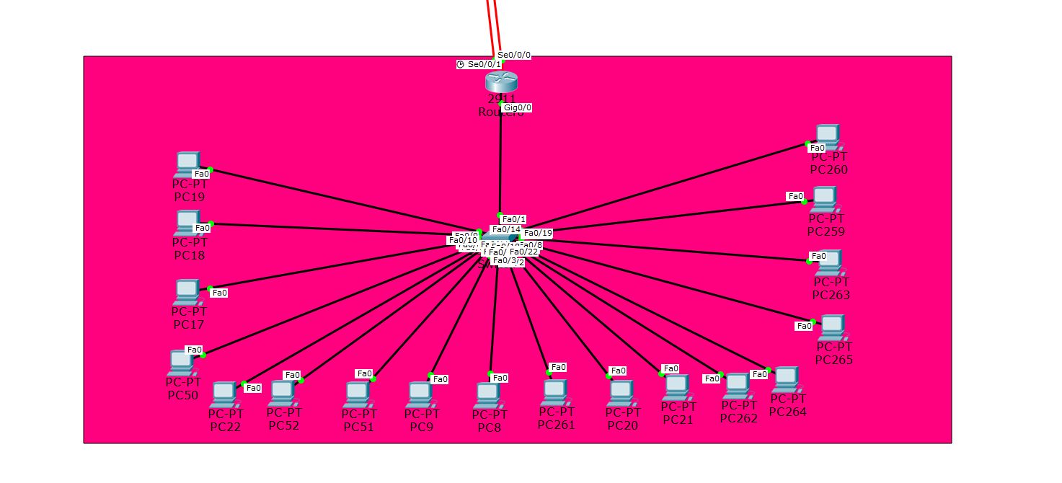
The above network represent emergency block in which there is one router, two switches and 48 computers.

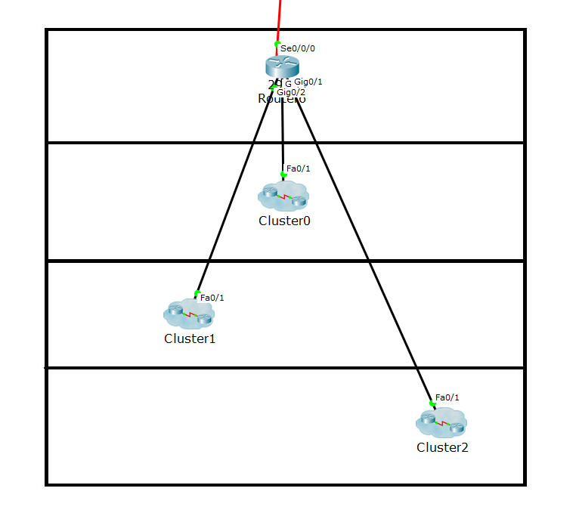
The above is network of education block. It has 3 switches and many computers connected to them

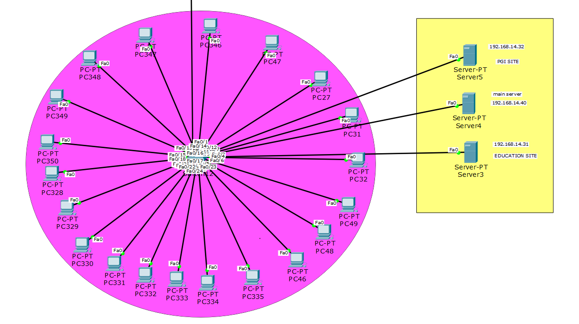
This is the internal structure of first switch inside education block cluster. This network has 1 switch, 3 servers and 20 computers

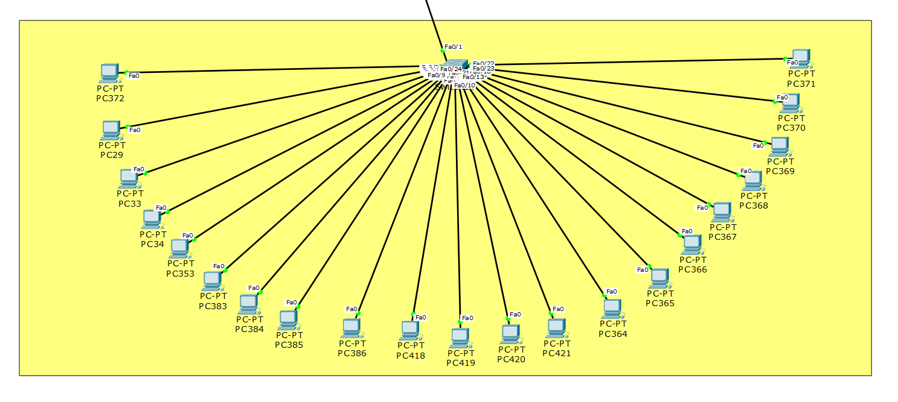

This is second sub network of educational block, Switch in this network is connected to the main router of education block.

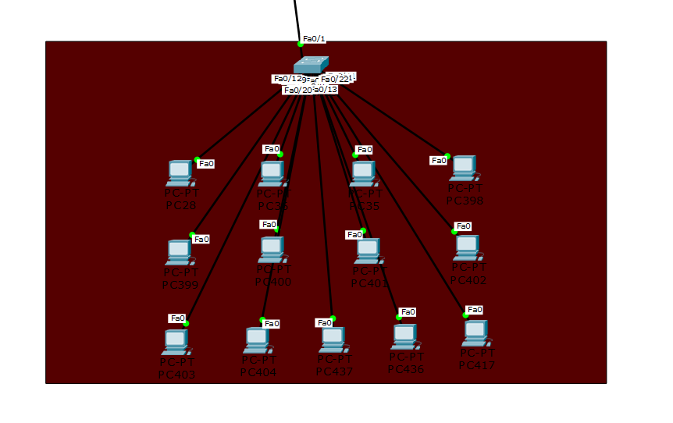

This is third sub network of educational block, Switch in this network is connected to the main router of education block. There are 13 computer connected in star topology to the switch.
To configure pc click on pc and go to desktop tab. Click on IP configuration to configure the pc
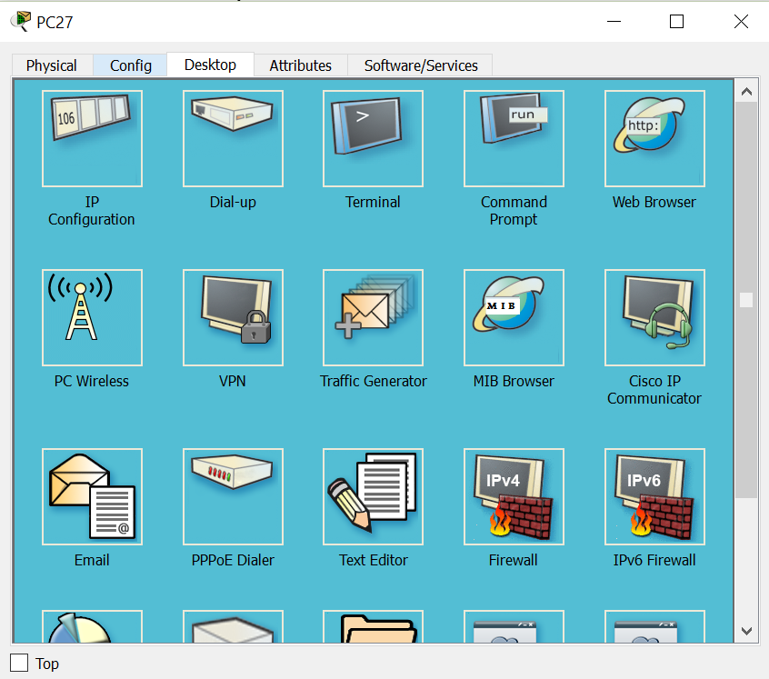

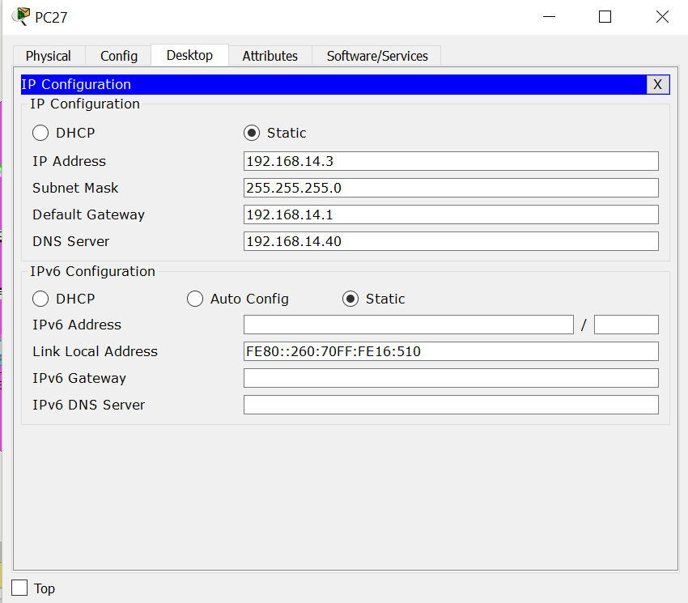

To set up servers and configure them, click on one of the added server and go to services and add all site related documents. The click on desktop and click on IP configuration and configure it.

PGI Server
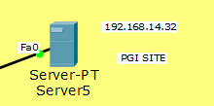

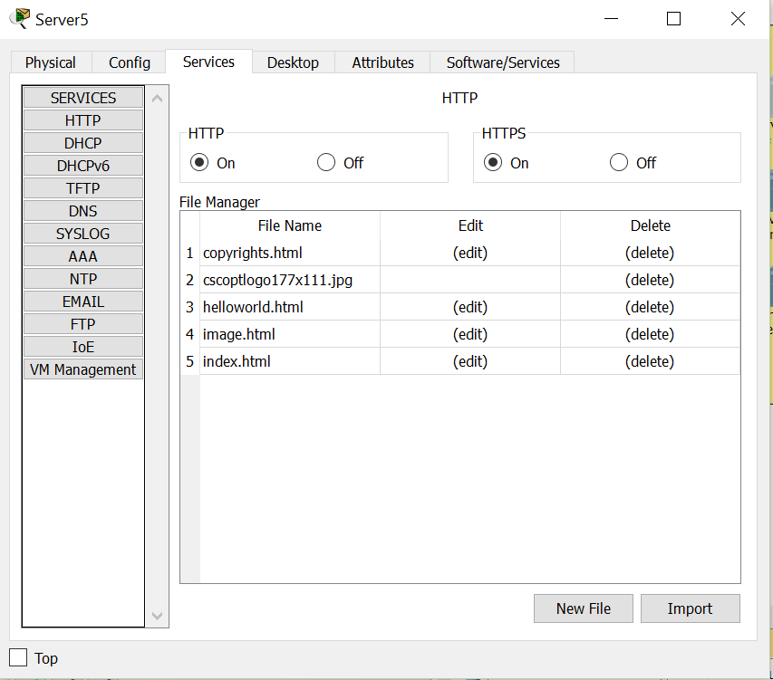

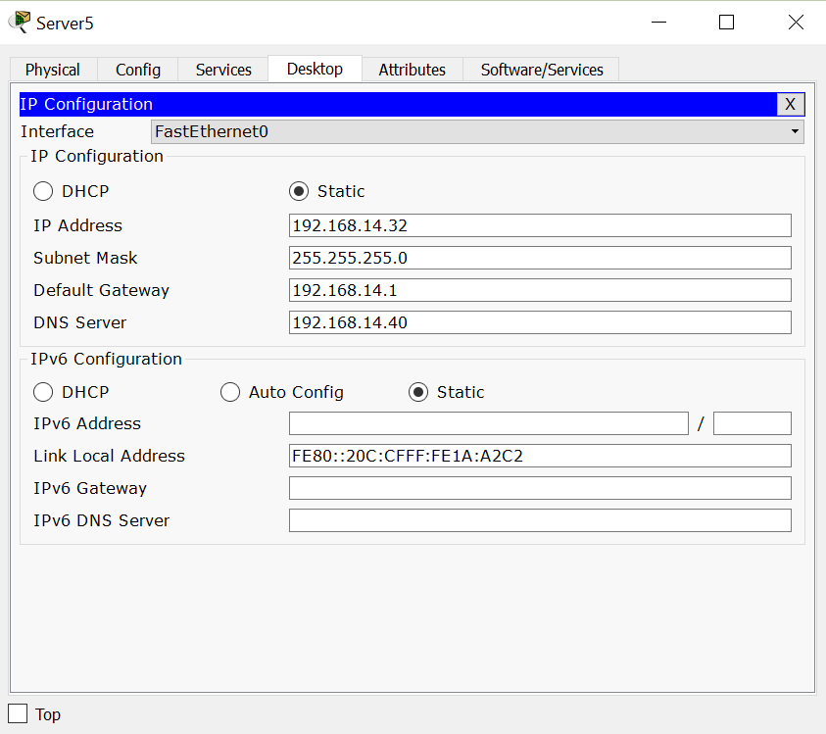

DNS Server
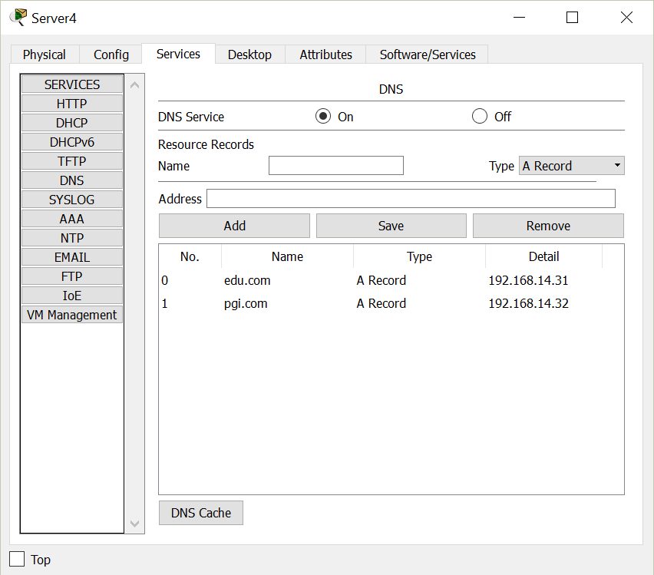

Enter IP and name to the site to get DNS service.
There are 2 internet sites that are hosted on 2 different servers which can be accessed by any computer in the network. Both the sites are hosted on a different server and they both have different IP addresses but they can be accessed by names i.e. pgi.com and edu.com due to DNS service.
There are 2 internet sites that are hosted on 2 different servers which can be accessed by any computer in the network. Both the sites are hosted on a different server and they both have different IP addresses but they can be accessed by names i.e pgi.com and edu.com due to DNS service.
To access to pgi site open web browser in any computer in the network, enter site name i.e. pgi.com and press enter . PGI site will open.
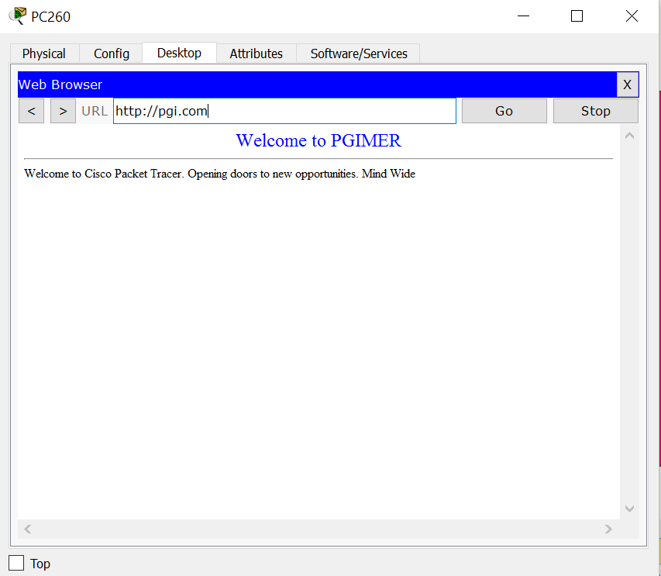
To can test the created network by sending packet from one computer to another
TESTING- PC 17 TO PC 106

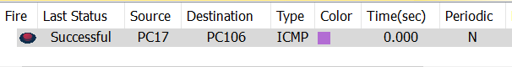

The packet is sent from PC17, the packet first reaches to the switch and then router. The router guides the packet towards the destination. The packet is recived by the local router of the target PC. The router then forwards to packet to the target PC and the packet is recived by PC106 successfully.

Acknowledgment
While presenting this report i would like to express my deep sense of gratitude to Professor Er. Inderjeet Singh was an indispensable part of my training giving me unending guidance, inspiration, encouragement and providing me an excellent environment throughout my training at Chandigarh University. The training was an extremely productive & enriching experience, not only technically but also from providing practical skills.
We are extremely thankful to her who had devoted a lot of time in guiding and supervising me during my training. We place our gratitude towards her valuable advice and guidance in carrying out this enjoyable and productive experience, which provided me a great opportunity to search for new horizons.

References
- https://pdfs.semanticscholar.org/6c81/67d8387605faafa45fc92927e168ea07e0b3.pdf
- Archana, C. "Analysis of RIPv2, OSPF, EIGRP Configuration on router Using CISCO Packet tracer." International journal of Engineering science and innovative technology (IJESIT) volume 4 (2015).
- https://en.wikipedia.org/wiki/Packet_Tracer

